The Creative Process
ROUGH LAYOUTS ASSIGNMENT
Worth 15% of final mark

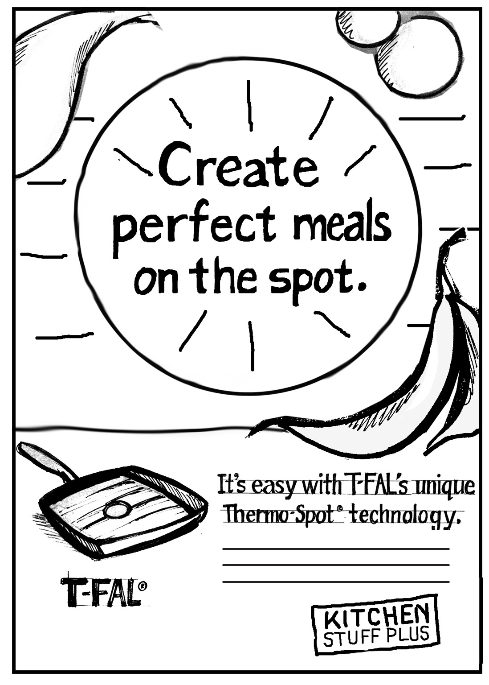

Getting your ideas down on paper.
- Using the creative strategy you have developed, create at least 5 hand-drawn rough concepts
based on original ideas for your chosen brand/product/service.

What creative is required?
Minimum of 5 different rough concept drawings.

- Each concept should have a headline and a visual and show a clearly different creative approach from the other ideas you come up with. The headlines and visuals must work together as a concept.
- The ideas should be clear and communicate a benefit to the consumer.
- The ideas should address your primary target audience and meet your objective.
- These roughs are to be hand-drawn layouts (see example provided) on 8.5” x 11” paper. They must also be submitted on Slate as a single PDF prior to class that day.
- FOLLOW THE TEMPLATE: One sketch per page. Write the fact, benefit, target and main message neatly and legibly above the sketch, so you can focus on that fact or benefit while you are coming up with ideas.
- If you can’t draw your idea in a way that communicates the concept, use written explanations or photos along with your sketch to help communicate your idea.

When is the creative due?
See Slate. I will give you written feedback for the roughs and you will choose three to go forward with to make into digital layouts.

What is it worth?
The project is worth 15% of your final mark.

IMPORTANT:
Please note that these ideas MUST be original and entirely of your own making. Copying ideas from the internet or the work of others will result is not acceptable.

